1. ing=np.arange(missing_df.shape[0])

fig, ax=plt.subplots(figsize=(15, 15))

ax.set_yticks(ing)

ax.set_yticklabels(missing_df.column_name)

ax.set_xlabel('Count of missing values')

ax.set_title('Number of missing values in each column', fontsize='20')

rects = ax.barh(ing, missing_df.missing_count.values, color='blue')

plt.show()

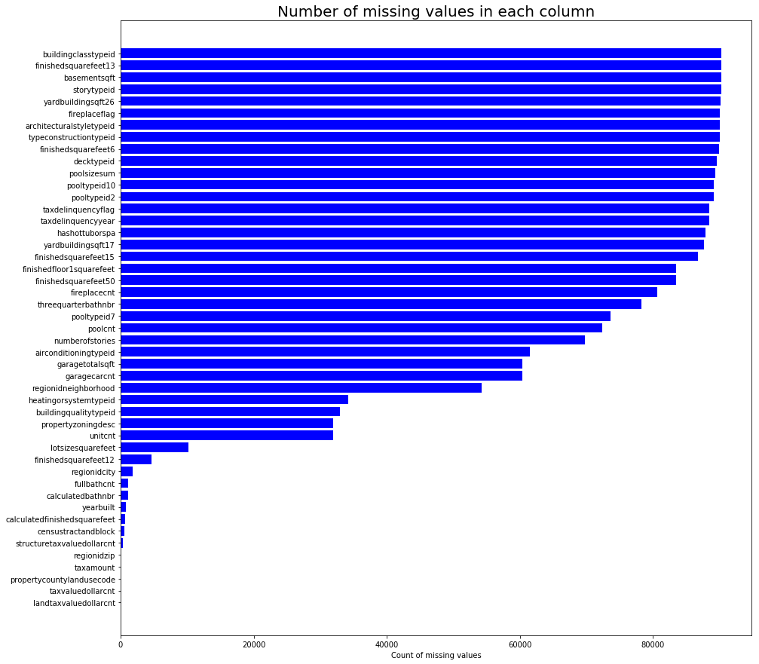

2. fig = plt.figure(figsize=[12, 6])

ax = fig.add_subplot(2,2,1)

rects = ax.bar([1,2,3,4,5], [1,2,4,8,16])

ax.xaxis.set_visible(True)

ax.yaxis.set_visible(False)

# ax.spines['bottom'].set_visible(False)

# ax.spines['top'].set_visible(False)

# ax.spines['left'].set_visible(False)

# ax.spines['right'].set_visible(False)

for x, y in ax.spines.items():

y.set_visible(False)

ax.set_xticks([1,2,3,4,5])

ax.set_xticklabels(['A', 'B', 'C', 'D', 'E'], fontdict={'fontsize': 20})

for rect in rects:

height = rect.get_height()

ax.text(rect.get_x() + rect.get_width()/2.,

height + 0.05,

'%d' % int(height),

fontdict={'fontsize': 20},

withdash=False,

ha='center', va='bottom')

# plt.xlabel('X Label', fontdict={'fontsize': '20'})

# ax.set_xlabel('X Label', fontdict={'fontsize': '20'})

ax.set_ylabel('Y Label', fontdict={'fontsize': '20'})

_ = ax.set_title('Test figure', fontdict={'fontsize': '20'})

# _ = ax.set_title('Test figure')

ax1 = fig.add_subplot(2,2,4)

ax1.plot([1,2,3])

# plt.xlabel('X Label', fontdict={'fontsize': '20'})

ax.set_xlabel('X Label', fontdict={'fontsize': '20'})

# fig.savefig('a.png', dpi=100)

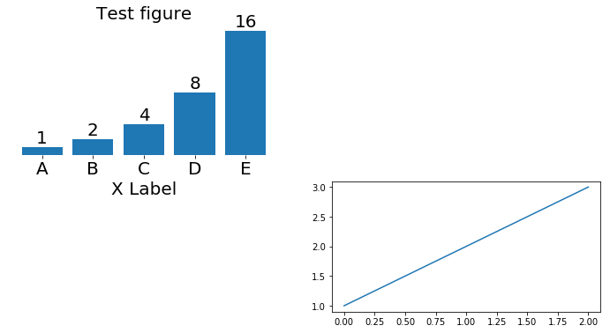

3. ROC Curve

%matplotlib inline

import matplotlib.pyplot as plt

# Hint: first argument is true values, second argument is predicted probabilities

fpr, tpr, thresholds = metrics.roc_curve(y_test, y_pred_prob)

plt.plot(fpr, tpr)

plt.xlim([0.0, 1.0])

plt.ylim([0.0, 1.0])

plt.title('ROC curve for diabetes classifier')

plt.xlabel('False Positive Rate (1 - Specificity)')

plt.ylabel('True Positive Rate (Sensitivity)')

plt.grid(True)

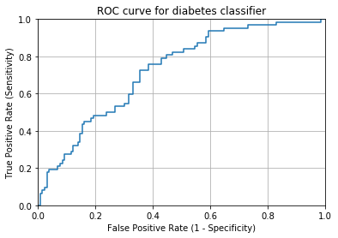

4. X,Y = datasets.make_blobs(n_samples=200, n_features=2, centers=2, random_state=1234)

plt.style.use('ggplot')

plt.scatter(X[:,0], X[:,1], c=Y)

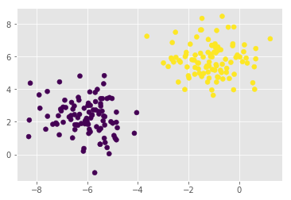

MiniProject3

